Background

Problem

Goals

Success Metrics

Key Features & Scope

Core UX Flow

### 

### **Background**

Research has shown that over 200 million students graduate each year, whereas just only 51% of them would be hired during 6 months after graduation (2020).

Approximately 100 million freshers would be unemployed, which brings several negative aspects to the economic development worldwide.

LinkedIn is an employment-oriented service, which is used for looking for professional job opportunities popularly in the world.

Recently, there are many similar platforms that focus on the new target users - graduated students every year.

### 

### 

### **Problem**

Nowadays, there has been an increasing number of companies, which provide job recommendations and excellent features for that mean of users.

Several graduated students have faced a lot of difficulties looking for their first job that is suitable with their professional skills as well as their expectation in the future. The primary reasons are a lack of soft skills like interview or negotiation, no experience in working environment in businesses and career path’s direction.

Struggles with freshers to start a professional career:

* *Lack of work experiences in enterprises’ environments*
* *Lack of soft-skills (interview, communication, …)*
* *Have no clear career paths*

### **Goals**

* Build a system help users create and review resume
* Provide numerous online courses and certificate
* Apply AI in suggesting students’ profile to recruiters
* Recommend jobs

### **Key Features**

1. **Resume**

* CV’s system for users to upgrade their resume with the suggestion from AI.
* This is a crucial feature to build the fundamental background for users and attract the recruiters.
* Increase the acceptance rate of the 1st round (CV)

1. **Online Course**

* Training courses provide a lot of information for freshers to enhance their professional skills (marketing, computer science,...) and their soft skills (interview, presentation, negotiation, …)
* This is a supportive foundation that helps college graduates be outstanding in the next stages.

1. **Job Recommendation**

* Based on the professional and soft skills as well as the created resume, there are several suggestions about the suitable jobs for students.
* This is a vital step in the process of applying for a job, which could have positive impacts on the result of acceptance rate.
* Feature allows freshers to access the potential career of their aspects and directs them to follow.

### **Success Metrics**

* Rate on App store & Google play: **4.5\***
* Churn Rate: **<10%**
* Weekly active users: **500k**

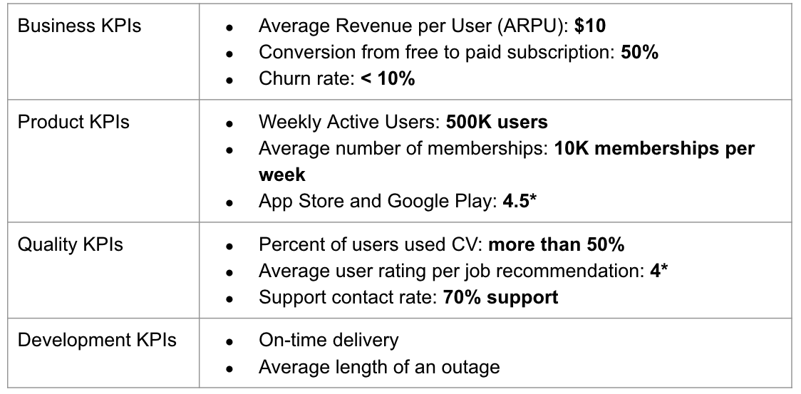

### **Target Market**

### LinkedIn Grad will focus on freshers of the global workforce by providing the fundamental step for their career such as an excellent resume, advanced professional and soft skills and the suitable job recommendations.

### **Total Addressable Market**

TAM = 200M students per year X $120 (annually) = $24B

**Potential Market:**

* China *(27% of global in 2030)*
* India *(23% of global in 2030)*
* US *(8% of global in 2030)*

Data Resource: [link](https://monitor.icef.com/2019/07/oecd-number-of-degree-holders-worldwide-will-reach-300-million-by-2030/)

**Competitors**

1. Indeed (Data Source: [Link](https://comparecamp.com/indeed-com-review-pricing-pros-cons-features/))

| Product Available | * Website * Mobile Application |
| --- | --- |
| Features | * Resume builder * Job listing * Messaging * Email Job Alert |
| Users | * Worldwide market |
| Differentiators | * Schedule and conduct virtual interview * Free trial (unlimited) |
| Price | * Free (starting from 5$ for recruiter) |

1. Glassdoor (Data source: [Link](https://www.getapp.com/hr-employee-management-software/a/glassdoor/))

| Product Available | * Website * Mobile Application |
| --- | --- |
| Features | * Listing jobs * Personal branding * Review company * Access salary databases |
| Users | * Worldwide users |
| Differentiators | * Job satisfaction rate |
| Price | * Free |

### 

### **Core UX Flow *(optional)***

[Link](https://www.figma.com/proto/accpHLbLQ2NT3Aj9XO9vZX/courses?node-id=1%3A2&scaling=scale-down&page-id=0%3A1&starting-point-node-id=1%3A2&show-proto-sidebar=1)

[Link](https://www.figma.com/proto/mcWS07eQc0BPFlxIEcriRz/createCV?node-id=2%3A2&starting-point-node-id=2%3A2)

### **Marketing and Pricing Strategy**

**Acquisition channels**

**1.** Partnership with universities and colleges or academic organization

* We will build a strong connection with universities and colleges or academic organization, which leads to students’ awareness about LinkedIn Grad
* This channel will be affordable and reach targeted users effectively.

2. Education and studying KOLs.

* Targeted users are college graduates, who often use social media platforms. KOLs are the influential people, who could bring a lot of benefits to the marketing campaign.
* This channel will be medium cost for advertisement and high impact.

3. App store and Play store review.

* Send the app for the market review. This process is a great way to tell users about a new mobile application and features.
* This channel will be costly and take time but will have a really high impact.

**Marketing Guide**: [Link](https://docs.google.com/document/d/1nBqxCLS0WgwGTAVMyCNujjFGSCASOzRMNCnTcd8CpNE/edit?usp=sharing)

**Benefits to users:**

* building profiles and networks
* creating resumes
* applying for jobs.
* Reviewing resumes by AI systems
* Online courses
* Certificates
* Job recommendations.

## **Details**:

Users can download the app from Google Play Store for android OS and App Store for iOS easily and conveniently.

**Pricing**

Users could access some free features such as building profiles and networks, creating resumes and applying for jobs.

However, they need membership to access reviewing resumes by AI systems, online courses, certificates, and job recommendations.

**Premium packages:**

* **1 month: 12$**
* **3 months: 10$/month**
* **Annual package: 8$/month**

| Year | Users | Memberships | Total |
| --- | --- | --- | --- |
| 1 | 1M | 100k | 1M |
| 2 | 3M | 500k | 5M |
| 2 | 5M | 1M | 10M |

**Preparing for Launch**

**Checklist:**

1. Engineering Team:

*=> Are there technical obstacles or technical debt?*

2. QA Team:

*=> Are all features working correctly? Are there any missing risks?*

3. Sales Team:

*=> Provide documents to the team and have a meeting to discuss the product and users.*

4. Marketing Team:

*=> Discuss about marketing strategy, proposition, messaging, acquisition channels.*

5. Customer Services:

*=> Discuss on user guide*

6. Legal

*=> Is the product legal?*

**Risks and Mitigation plan:**

1. **Miscommunication:**

* Description: *We need to make sure the conversation between all stakeholders about the projects’ progress. Lack of knowledge or resources could result in bad user experiences as well as decline the conversion rate.*
* Mitigation: *A detailed training guide for customer support about product features. Maintaining daily stand-up meetings to resolve problems immediately.*

1. **Technical debt:**

* Description: *The changes of source code could increase the risky proportion, such as slowly loading pages or crash app.*
* Mitigation: *Discuss with Dev team and QA team to ensure we have no technical debt and have enough resources to scale up. Preparing backup plans for all scenarios.*

1. **Competitors** **campaign**

* Description: *Our product has to face many struggles related to other competitors during the launching process. Taking advantages of LinkedIn already network is crucial to alleviate the impact of this type of risk*
* Mitigation: *Create a strong connection with users through customer services and partnership among universities, college and academic organizations. Follow up the social media platforms to enhance our position if needed.*

*Training Guide for customer services and sales:* [*LINK*](https://docs.google.com/document/d/1Zd94gReJDreCmYXjpG5_a0z1pPl7fgBgfXWarb6emxs/edit?usp=sharing)

*User Guide:* [*LINK*](https://docs.google.com/document/d/14q7e7-EVQ4rJCXDSwwF2VRNh4WV-Ls-H_F6Rn3n_zLg/edit?usp=sharing)

**Post-launch Activities:**

Feedback: After launching your product, you notice that the adoption rate is lower than you expected (about 35%). How would you investigate the reasons and suggest potential solutions?

* Investigate users => assume data for graph

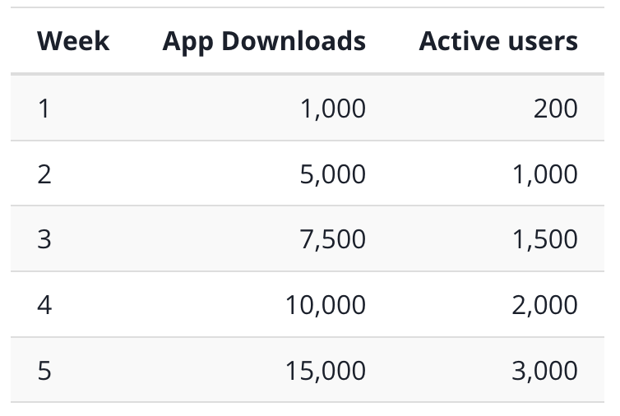

**Assumptions**:

1. Users are not familiar with the process of creating a resume

Solution:

* Discuss with product designers to improve the UI of LinkedIn Grad during the creating resume.
* Discuss with the dev team to find out the solution to enhance the quality of templates CV and job recommendation.

Control:

* User access screen ‘create CV’ from their profile screen.
* User select some fields of resume

Variant:

* There are available field suggestion for selecting
* Provide user guide

Hypothesis:

* User could conveniently create CV that follows the available templates
* The percentage of active users and amount of resumes on the system are inclined quickly.

1. Users complaint the quality of AI reviewing is not matched

Solution:

* Discuss with data and AI team to find out the solution to enhance the quality of reviewing CV and job recommendation.

Control:

* Job recommendation was resulted from CV

Variant:

* Based on certificates, skills and CV to return the job recommendations

Hypothesis:

* Users could receive the more suitable suggestion than before.
* The quality of recruiting process is increased considerably

Launch Email: [Link](https://docs.google.com/document/d/1ZztByy_NAMk-eFo0g9ma_Gqrw3W6uZpBZUJPDM_x4GM/edit?usp=sharing)